# Airline Booking System

## [Airline Booking System Activity Diagram](https://www.freeprojectz.com/uml-diagram/airline-booking-system-activity-diagram)

This is the **Activity UML diagram of Airline Booking System** which shows the flows between the activity of Booking Enquiry, Airline Enquiry, Airlines Booking, Ticket Booking, Passengar. The main activity involved in this **UML Activity Diagram of Airline Booking System** are as follows:

* Booking Enquiry Activity
* Airline Enquiry Activity
* Airlines Booking Activity
* Ticket Booking Activity
* Passengar Activity

## Features of the Activity UML diagram of Airline Booking System

* Admin User can search Booking Enquiry, view description of a selected Booking Enquiry, add Booking Enquiry, update Booking Enquiry and delete Booking Enquiry.
* Its shows the activity flow of editing, adding and updating of Airline Enquiry
* User will be able to search and generate report of Airlines Booking, Ticket Booking, Passengar
* All objects such as ( Booking Enquiry, Airline Enquiry, Passengar) are interlinked
* Its shows the full description and flow of Booking Enquiry, Ticket Booking, Passengar, Airlines Booking, Airline Enquiry

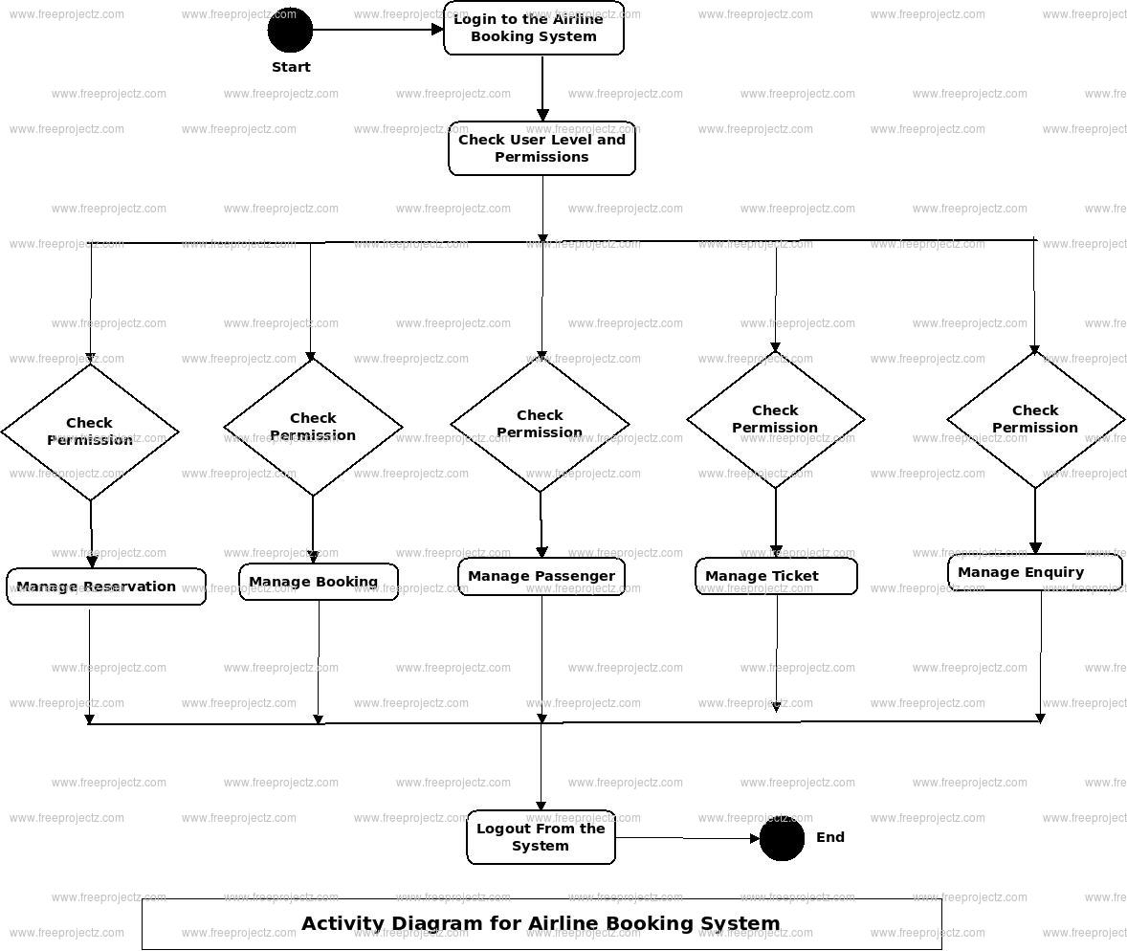

## Login Activity Diagram of Airline Booking System:

This is the **Login Activity Diagram of Airline Booking System**, which shows the flows of Login Activity, where admin will be able to login using their username and password. After login user can manage all the operations on Airlines Booking, Booking Enquiry, Airline Enquiry, Passengar, Ticket Booking. All the pages such as Airline Enquiry, Passengar, Ticket Booking are secure and user can access these page after login. The diagram below helps demonstrate how the login page works in a Airline Booking System. The various objects in the Passengar, Airlines Booking, Booking Enquiry, Airline Enquiry, and Ticket Booking page—interact over the course of the Activity, and user will not be able to access this page without verifying their identity.

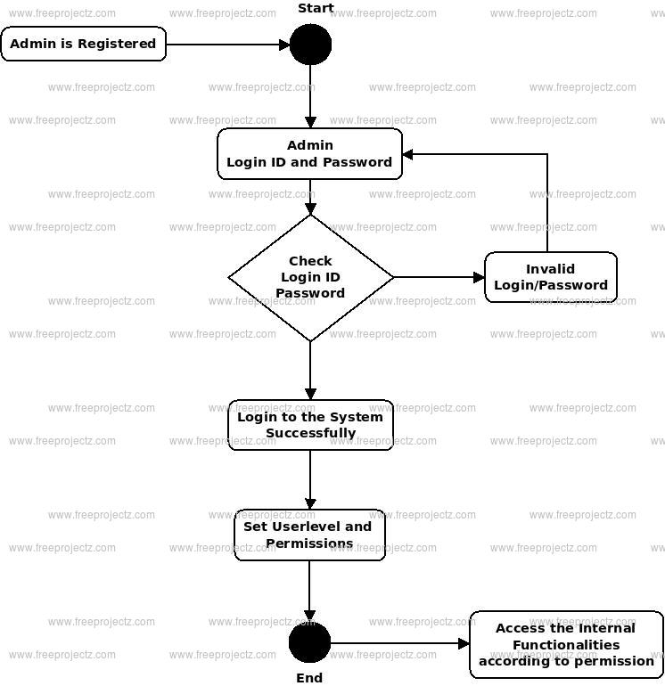

## [Airline Booking System Class Diagram](https://www.freeprojectz.com/uml/airline-booking-system-class-diagram)

Airline Booking System Class Diagram describes the structure of a Airline Booking System classes, their attributes, operations (or methods), and the relationships among objects. The main classes of the Airline Booking System are Ticket, Airlines Booking, Passenger, Ticket, Booking Enquiry,, Airline Enquiry.

#### Classes of Airline Booking System Class Diagram:

* **Ticket Class** : Manage all the operations of Ticket
* **Airlines Booking Class** : Manage all the operations of Airlines Booking
* **Passenger Class** : Manage all the operations of Passenger
* **Ticket Class** : Manage all the operations of Ticket
* **Booking Enquiry, Class** : Manage all the operations of Booking Enquiry,
* **Airline Enquiry Class** : Manage all the operations of Airline Enquiry

#### Classes and their attributes of Airline Booking System Class Diagram:

* **Ticket Attributes** : ticket_id, ticket_customer_id, ticket_type, ticket_date, ticket_description
* **Airlines Booking Attributes** : airlines booking_id, airlines_passenger_id, airlines booking_type, airlines booking_date, airlines booking_description
* **Passenger Attributes** : passenger_id, passenger_name, passenger_mobile, passenger_email, passenger_username, passenger_password, passenger_address
* **Ticket Attributes** : ticket_id, ticket_type, ticket_booking_id, ticket_Date, ticket_description
* **Booking Enquiry, Attributes** : booking enquiry,_id, booking enquiry,_title, booking enquiry,_type, booking enquiry,_date, booking enquiry,_description
* **Airline Enquiry Attributes** : airline enquiry,_id, airline enquiry,_title, airline enquiry,_type, airline enquiry,_date, airline enquiry,_description

#### Classes and their methods of Airline Booking System Class Diagram:

* **Ticket Methods** : addTicket(), editTicket(), deleteTicket(), updateTicket(), saveTicket(), searchTicket()
* **Airlines Booking Methods** : addAirlines Booking(), editAirlines Booking(), deleteAirlines Booking(), updateAirlines Booking(), saveAirlines Booking(), searchAirlines Booking()
* **Passenger Methods** : addPassenger(), editPassenger(), deletePassenger(), updatePassenger(), savePassenger(), searchPassenger()
* **Ticket Methods** : addTicket(), editTicket(), deleteTicket(), updateTicket(), saveTicket(), searchTicket()
* **Booking Enquiry, Methods** : addBooking Enquiry,(), editBooking Enquiry,(), deleteBooking Enquiry,(), updateBooking Enquiry,(), saveBooking Enquiry,(), searchBooking Enquiry,()
* **Airline Enquiry Methods** : addAirline Enquiry(), editAirline Enquiry(), deleteAirline Enquiry(), updateAirline Enquiry(), saveAirline Enquiry(), searchAirline Enquiry()

#### Class Diagram of Airline Booking System :

Class Diagram Image:

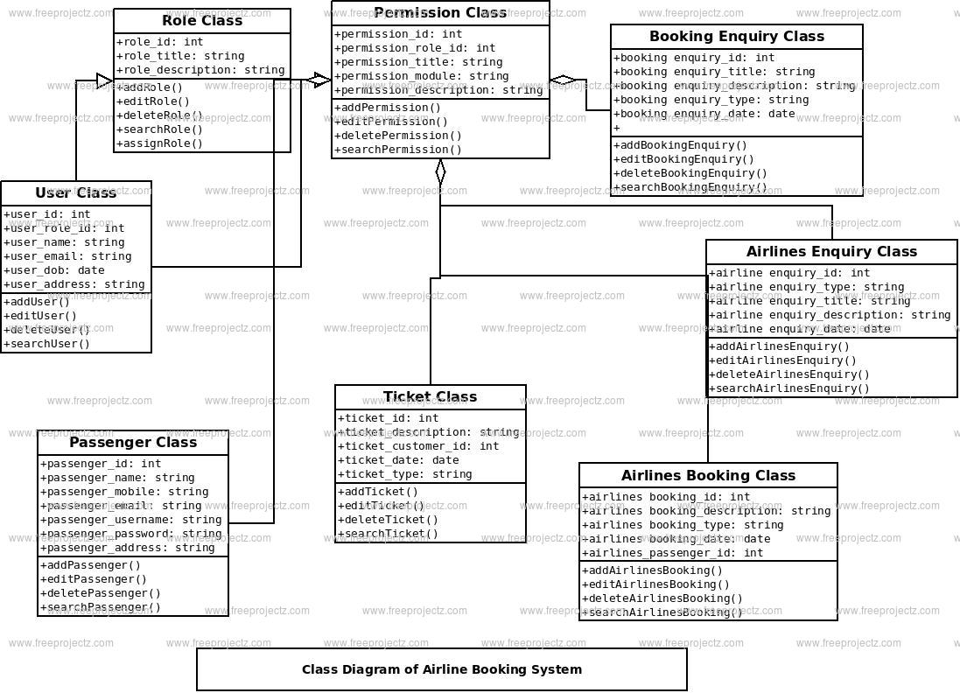

## [Airline Booking System Component Diagram](https://www.freeprojectz.com/uml-diagram/airline-booking-system-component-diagram)

This is a **Component diagram of Airline Booking System** which shows components, provided and required interfaces, ports, and relationships between the Booking Enquiry, Passengar Reservation, Airlines Booking, Airline Enquiry and Ticket Booking. This type of diagrams is used in Component-Based Development (CBD) to describe systems with Service-Oriented Architecture (SOA). **Airline Booking System UML component diagram**, describes the organization and wiring of the physical components in a system.

#### Components of UML Component Diagram of Airline Booking System:

* Booking Enquiry Component
* Passengar Reservation Component
* Airlines Booking Component
* Airline Enquiry Component
* Ticket Booking Component

#### Featues of Airline Booking System Component Diagram:

* You can show the models the components of Airline Booking System.
* Model the database schema of Airline Booking System
* Model the executables of an application of Airline Booking System
* Model the system's source code of Airline Booking System

Component Diagram:

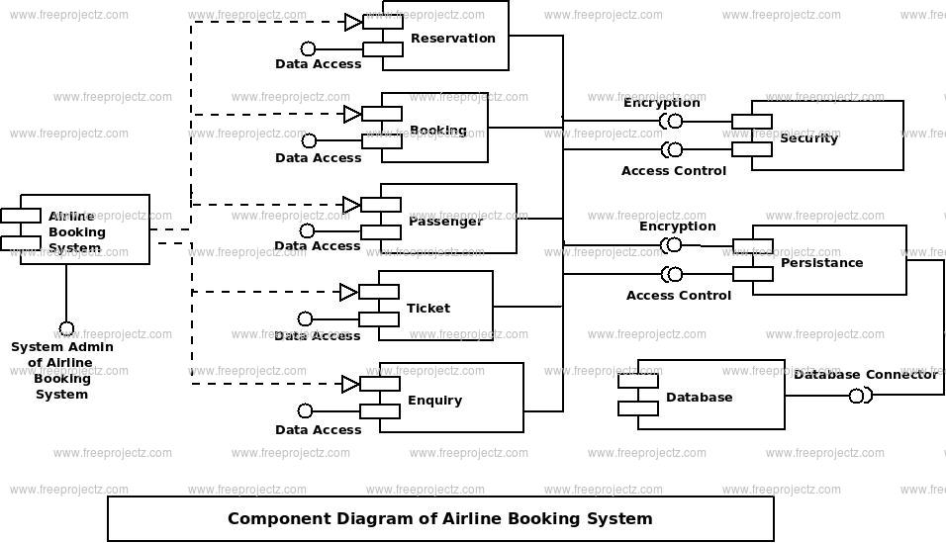

## [Airline Booking System Dataflow Diagram](https://www.freeprojectz.com/dfd/airline-booking-system-dataflow-diagram)

Airline Booking System Data flow diagram is often used as a preliminary step to create an overview of the Airline without going into great detail, which can later be elaborated.it normally consists of overall application dataflow and processes of the Airline process. It contains all of the userflow and their entities such all the flow of Passenger Reservation, Airline Booking, Passenger, Ticket Booking, Booking Enquiry, Airline Enquiry, Login. All of the below diagrams has been used for the visualization of data processing and structured design of the Airline process and working flow.

## Zero Level Data flow Diagram(0 Level DFD) of Airline Booking System :

This is the Zero Level DFD of Airline Booking System, where we have eloborated the high level process of Airline. It’s a basic overview of the whole Airline Booking System or process being analyzed or modeled. It’s designed to be an at-a-glance view of Booking Enquiry,Airline Enquiry and Login showing the system as a single high-level process, with its relationship to external entities of Passenger Reservation, Airline Booking and Passenger. It should be easily understood by a wide audience, including Passenger Reservation, Passenger and Booking Enquiry In zero leve DFD of Airline Booking System, we have described the high level flow of the Airline system.

#### High Level Entities and proccess flow of Airline Booking System:

* Managing all the Passenger Reservation
* Managing all the Airline Booking
* Managing all the Passenger
* Managing all the Ticket Booking
* Managing all the Booking Enquiry
* Managing all the Airline Enquiry
* Managing all the Login

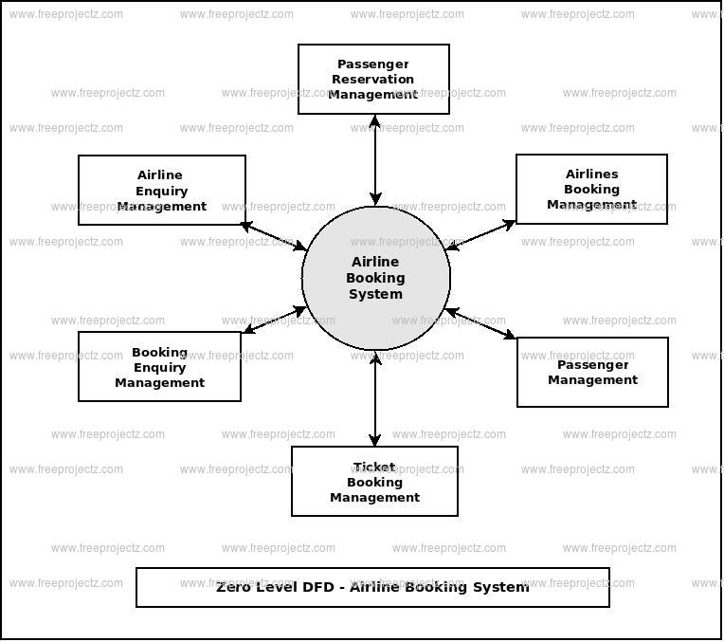

## First Level Data flow Diagram(1st Level DFD) of Airline Booking System :

First Level DFD (1st Level) ofAirline Booking System shows how the system is divided into sub-systems (processes), each of which deals with one or more of the data flows to or from an external agent, and which together provide all of the functionality of theAirline Booking System system as a whole. It also identifies internal data stores of Login, Airline Enquiry, Booking Enquiry, Ticket Booking, Passenger that must be present in order for the Airline system to do its job, and shows the flow of data between the various parts of Passenger Reservation, Passenger, Airline Enquiry, Login, Booking Enquiry of the system. DFD Level 1 provides a more detailed breakout of pieces of the 1st level DFD. You will highlight the main functionalities of Airline.

#### Main entities and output of First Level DFD (1st Level DFD):

* Processing Passenger Reservation records and generate report of all Passenger Reservation
* Processing Airline Booking records and generate report of all Airline Booking
* Processing Passenger records and generate report of all Passenger
* Processing Ticket Booking records and generate report of all Ticket Booking
* Processing Booking Enquiry records and generate report of all Booking Enquiry
* Processing Airline Enquiry records and generate report of all Airline Enquiry
* Processing Login records and generate report of all Login

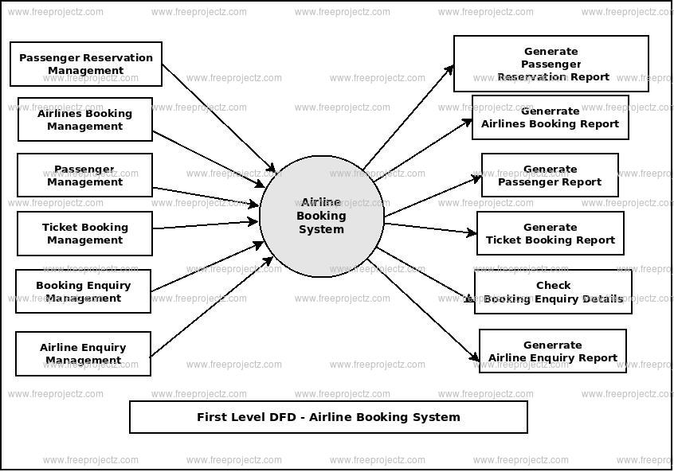

## Second Level Data flow Diagram(2nd Level DFD) of Airline Booking System :

DFD Level 2 then goes one step deeper into parts of Level 1 of Airline. It may require more functionalities of Airline to reach the necessary level of detail about the Airline functioning. First Level DFD (1st Level) ofAirline Booking System shows how the system is divided into sub-systems (processes). The 2nd Level DFD contains more details of Login, Airline Enquiry, Booking Enquiry, Ticket Booking, Passenger, Airline Booking, Passenger Reservation.

#### Low level functionalities of Airline Booking System

* Admin logins to the system and manage all the functionalities of Airline Booking System
* Admin can add, edit, delete and view the records of Passenger Reservation, Passenger, Booking Enquiry, Login
* Admin can manage all the details of Airline Booking, Ticket Booking, Airline Enquiry
* Admin can also generate reports of Passenger Reservation, Airline Booking, Passenger, Ticket Booking, Booking Enquiry, Airline Enquiry
* Admin can search the details of Airline Booking, Booking Enquiry, Airline Enquiry
* Admin can apply different level of filters on report of Passenger Reservation, Ticket Booking, Booking Enquiry
* Admin can tracks the detailed information of Airline Booking, Passenger, Ticket Booking, , Booking Enquiry

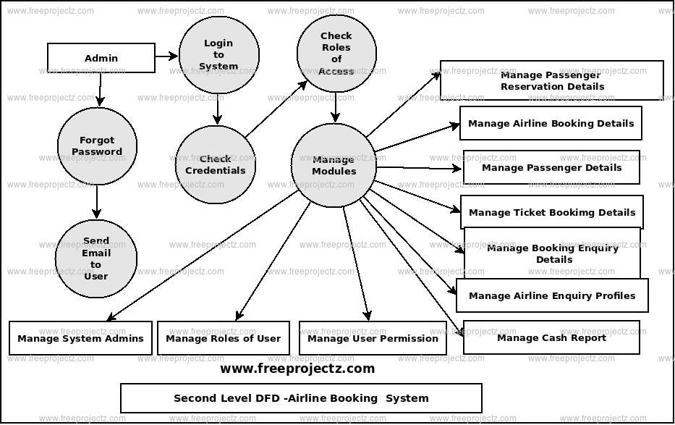

## [Airline Booking System ER Diagram](https://www.freeprojectz.com/entity-relationship/airline-booking-system-er-diagram)

This ER (Entity Relationship) Diagram represents the model of Airline Booking System Entity. The entity-relationship diagram of Airline Booking System shows all the visual instrument of database tables and the relations between Airlines Booking, Ticket, Ticket, Airline Enquiry etc. It used structure data and to define the relationships between structured data groups of Airline Booking System functionalities. The main entities of the Airline Booking System are Ticket, Airlines Booking, Passenger, Ticket, Booking Enquiry, and Airline Enquiry.

#### Airline Booking System entities and their attributes :

* **Ticket Entity** : Attributes of Ticket are ticket_id, ticket_customer_id, ticket_type, ticket_date, ticket_description
* **Airlines Booking Entity** : Attributes of Airlines Booking are airlines booking_id, airlines_passenger_id, airlines booking_type, airlines booking_date, airlines booking_description
* **Passenger Entity** : Attributes of Passenger are passenger_id, passenger_name, passenger_mobile, passenger_email, passenger_username, passenger_password, passenger_address
* **Ticket Entity** : Attributes of Ticket are ticket_id, ticket_type, ticket_booking_id, ticket_Date, ticket_description
* **Booking Enquiry, Entity** : Attributes of Booking Enquiry, are booking enquiry,_id, booking enquiry,_title, booking enquiry,_type, booking enquiry,_date, booking enquiry,_description
* **Airline Enquiry Entity** : Attributes of Airline Enquiry are airline enquiry,_id, airline enquiry,_title, airline enquiry,_type, airline enquiry,_date, airline enquiry,_description

#### Description of Airline Booking System Database :

* The details of Ticket is store into the Ticket tables respective with all tables
* Each entity (Airline Enquiry, Passenger, Booking Enquiry,, Airlines Booking, Ticket) contains primary key and unique keys.
* The entity Passenger, Booking Enquiry, has binded with Ticket, Airlines Booking entities with foreign key
* There is one-to-one and one-to-many relationships available between Booking Enquiry,, Ticket, Airline Enquiry, Ticket
* All the entities Ticket, Booking Enquiry,, Passenger, Airline Enquiry are normalized and reduce duplicacy of records
* We have implemented indexing on each tables of Airline Booking System tables for fast query execution.

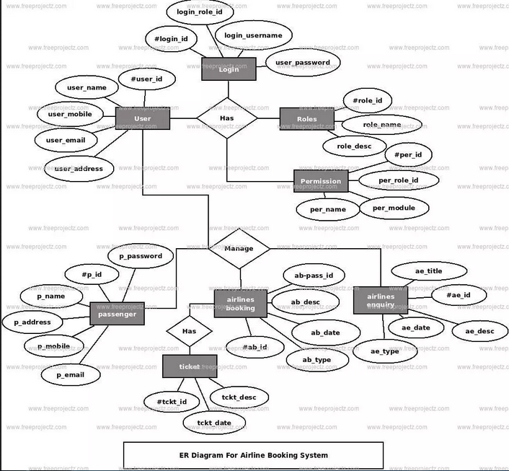

## [Airline Booking System Sequence Diagram](https://www.freeprojectz.com/uml-diagram/airline-booking-system-sequence-diagram)

This is the **UML sequence diagram of Airline Booking System** which shows the interaction between the objects of Booking Enquiry, Ticket Booking, Airline Enquiry, Airlines Booking, Passengar. The instance of class objects involved in this UML Sequence Diagram of Airline Booking System are as follows:

* Booking Enquiry Object
* Ticket Booking Object
* Airline Enquiry Object
* Airlines Booking Object
* Passengar Object

## Login Sequence Diagram of Airline Booking System:

This is the **Login Sequence Diagram of Airline Booking System**, where admin will be able to login in their account using their credentials. After login user can manage all the operations on Airline Enquiry, Booking Enquiry, Ticket Booking, Passengar, Airlines Booking. All the pages such as Ticket Booking, Passengar, Airlines Booking are secure and user can access these page after login. The diagram below helps demonstrate how the login page works in a Airline Booking System. The various objects in the Passengar, Airline Enquiry, Booking Enquiry, Ticket Booking, and Airlines Booking page—interact over the course of the sequence, and user will not be able to access this page without verifying their identity.

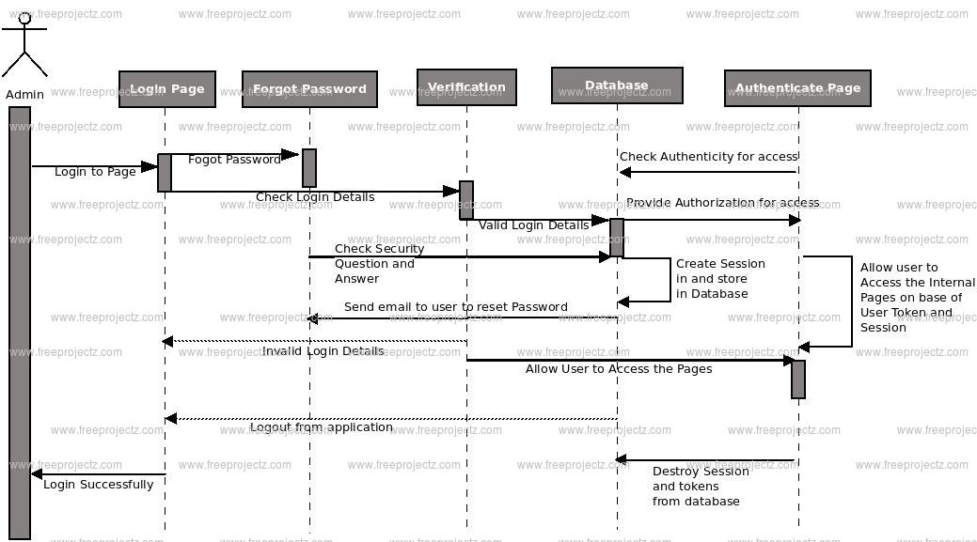

This is the **UML sequence diagram of Airline Booking System** which shows the interaction between the objects of Booking Enquiry, Ticket Booking, Airline Enquiry, Airlines Booking, Passengar. The instance of class objects involved in this UML Sequence Diagram of Airline Booking System are as follows:

* Booking Enquiry Object
* Ticket Booking Object
* Airline Enquiry Object
* Airlines Booking Object
* Passengar Object

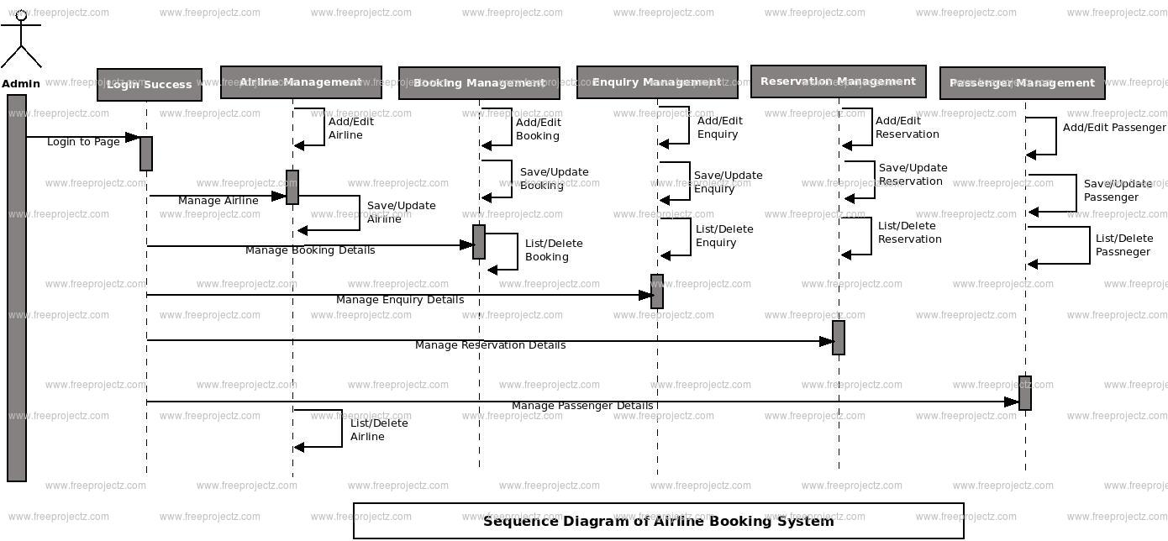

## [Airline Booking System Use Case Diagram](https://www.freeprojectz.com/use-case/airline-booking-system-use-case-diagram)

This Use Case Diagram is a graphic depiction of the interactions among the elements of Airline Booking System. It represents the methodology used in system analysis to identify, clarify, and organize system requirements of Airline Booking System. The main actors of Airline Booking System in this Use Case Diagram are: Super Admin, System User, Agent, Customer, who perform the different type of use cases such as Manage Ticket, Manage Airlines, Manage Booking, Manage Passenger, Manage Ticket Booking Enquiry, Manage Airline Enquiry, Manage Users and Full Airline Booking System Operations. Major elements of the UML use case diagram of Airline Booking System are shown on the picture below.

#### The relationships between and among the actors and the use cases of Airline Booking System:

* **Super Admin Entity** : Use cases of Super Admin are Manage Ticket, Manage Airlines, Manage Booking, Manage Passenger, Manage Ticket Booking Enquiry, Manage Airline Enquiry, Manage Users and Full Airline Booking System Operations
* **System User Entity** : Use cases of System User are Manage Ticket, Manage Airlines, Manage Booking, Manage Passenger,
* **Agent Entity** : Use cases of Agent are Book Customer Ticket, Create Enquiry, View Itiniary
* **Customer Entity** : Use cases of Customer are Book Ticket, Search Ticket, View Ticket, Login, Register

#### Use Case Diagram of Airline Booking System :

